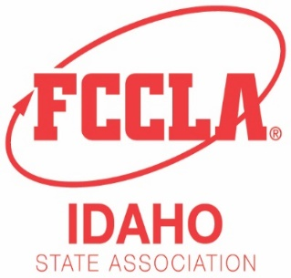
Idaho Family, Career and Community Leaders of America
650 W. State St. Suite 324
Boise, ID 83702
Phone: (208)-429-5525 - Email: mailto:fccla@cte.idaho.gov
www.idahofccla.org

January 3, 2022

Attached are the recipes and equipment lists that will be used for the Idaho District and State Culinary Arts and Baking & Pastry STAR Events competitions. The rubrics for these events are found in the 2021-2022 National Competitive Events Guide. The guide is found in the FCCLA portal under resources and competitive events.
The Culinary Arts STAR Event is an INDVIDUAL event for Level 3 students who are currently or have been enrolled in the Family and Consumer Sciences Culinary Arts capstone course. Students enrolled in cluster food and nutrition courses are not eligible. (see page 69, 2021-2022 Competitive Events Guide).

The Baking & Pastry STAR Event is an INDVIDUAL event for Level 3 students who are currently or have been enrolled in the Family and Consumer Sciences Culinary Arts pathway program. Students enrolled in cluster food and nutrition courses are not eligible. (see page 25, 2021-2022 Competitive Events Guide).

Please do not hesitate to email me with any questions or concerns you might have about competitive events this year at jwahlen@sd251.org or competitiveevents@idahofccla.org .

Jessica Wahlen
Rigby High School
Idaho FCCLA Competitive Events Coordinator

