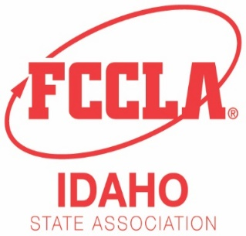
Idaho Family, Career and Community Leaders of America
650 W. State St. Suite 324
Boise, ID 83702
Phone: (208)-429-5525 - Email: mailto:fccla@cte.idaho.gov
www.idahofccla.org

January 6, 2022

Idaho FCCLA Advisers,
As we plan and prepare to return to an in-person Idaho FCCLA State Leadership Conference we are asking advisers to complete the following intent to compete form for their chapter by January 20th. https://forms.gle/LDw8dbi6gDqNeo8LA
The intent to compete form will help those planning Idaho FCCLA Competitive Events ensure that adequate kitchen space for Culinary Arts and Baking and Pastry is available and to help secure judges for the other events. This is not a registration form, simply a way for us to better prepare for competitive events this year. Please complete the form to the best of your knowledge. We understand that you may have changes to competitors and events when you register for district competition.
As a reminder, students competing in STAR Events need to be affiliated by February 1st and students competing in IDAHO Events need to be affiliated by March 1st.
Also, the event categories have changed to the following:
- Level 1 (through grade 8)
- Level 2 (grades 9-10)
- Level 3 (grades 11-12)
- Level 4 (Postsecondary)

Please be aware that some of the events have other eligibility requirements (eg. enrolled in a course in the Culinary Arts pathway) that are listed on the first page of the rubric under Eligibility and General Information. (Look for the red diamond with an exclamation point in the center) The STAR Events guidelines and rubrics can be found in the FCCLA portal under resources and competitive events.

Thank you for your dedication to Idaho FCCLA and your students. Please do not hesitate to email me with any questions or concerns you might have about competitive events this year at jwahlen@sd251.org or competitiveevents@idahofccla.org.

Jessica Wahlen
Rigby High School
Idaho FCCLA Competitive Events Coordinator

